QUESTION 1:
------------
Find the answer for below questions and tell whether it is possible or not?
A-abstract class
C-class
I- interface

I implements I - Possible
I implements C - Not possible
I implements A - Not Possible
I extends I - Possible
I extends C - Not Possible
I extends A - Not Possible

C implements I - Possible
C implements C - Not Possible
C implements A - Possible
C extends I - Not Possible
C extends C - Possible
C extends A - Possible

A implements I – Not Possible
A implements C – Not Possible
A implements A – Not Possible
A extends I – Not Possible
A extends C - Possible
A extends A – Possible
QUESTION 9:
------------
Project :BikeInformation
Package :org.bike
Interface :Bike
Methods :cost(),speed()

Class :Ktm
Methods :cost(),speed()

Description:
cost(),speed() is just a templete in Bike Interface and You have to override the method cost(),speed() in Ktm class.

Bike.java (interface) -

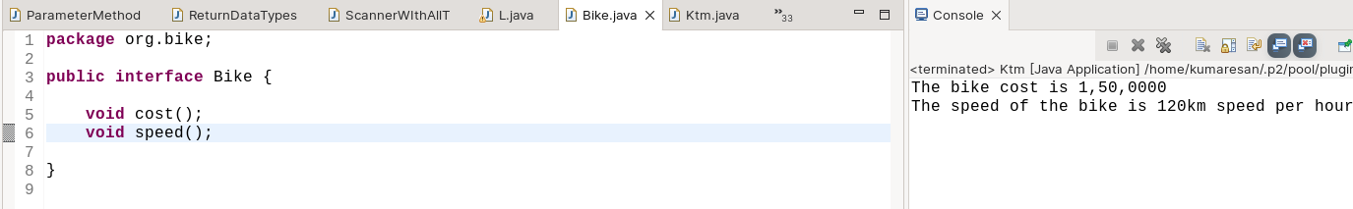
Ktm.java(class) -

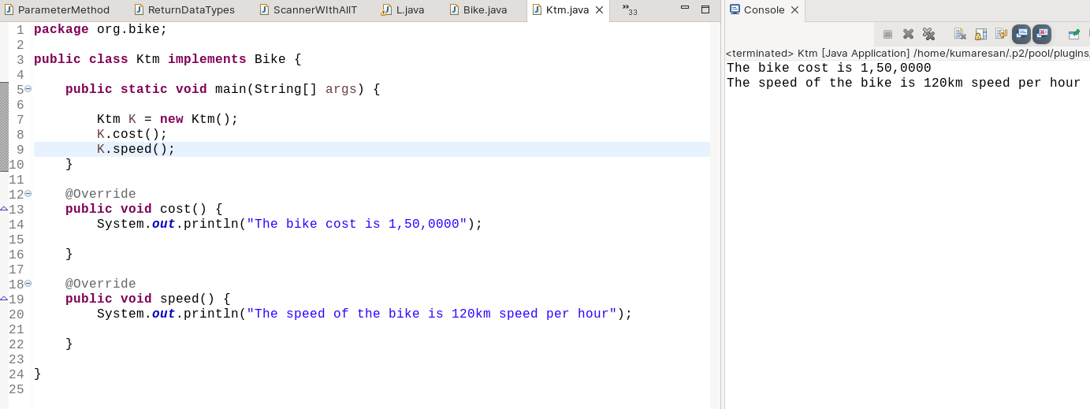
QUESTION 10:
-------------
Project :Computer
Interface :HardWare
Methods :hardwareResources()

Interface :Software
Methods :softwareResources()

Class :Desktop
Methods :desktopModel()

Description:
create 2 Interface and archieve multiple inheritance.

Software.java (interface) -

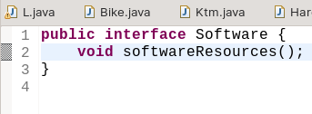
Hardware.java (interface) -

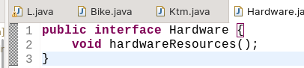

Desktop.java (class) -

